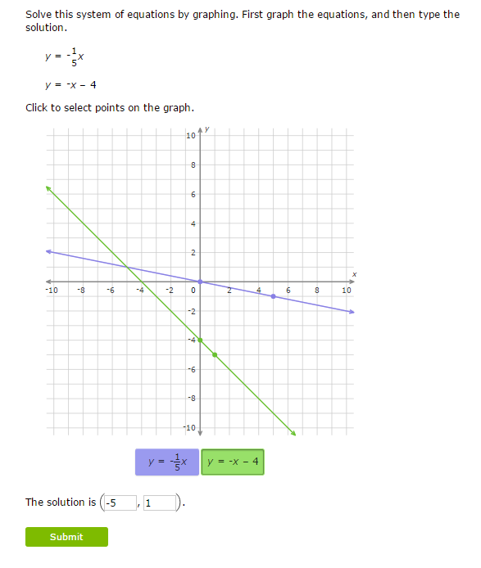

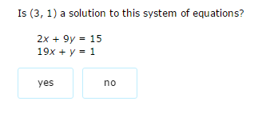

For problems 1 http://tutorial.math.lamar.edu/Problems/Alg/SystemsTwoVrble_files/empty.gifhttp://tutorial.math.lamar.edu/Problems/Alg/SystemsTwoVrble_files/ch0M.gifhttp://tutorial.math.lamar.edu/Problems/Alg/SystemsTwoVrble_files/empty.gif 3 use the Method of Substitution to find the solution to the given system or to determine if the system is inconsistent or dependent.

1. http://tutorial.math.lamar.edu/Problems/Alg/SystemsTwoVrble_files/eq0001MP.gifhttp://tutorial.math.lamar.edu/Problems/Alg/SystemsTwoVrble_files/empty.gifhttp://tutorial.math.lamar.edu/Problems/Alg/SystemsTwoVrble_files/eq0001M.gifhttp://tutorial.math.lamar.edu/Problems/Alg/SystemsTwoVrble_files/empty.gif

[[**Solution**](javascript:GetSolution('350,1'))]

2. http://tutorial.math.lamar.edu/Problems/Alg/SystemsTwoVrble_files/eq0002MP.gifhttp://tutorial.math.lamar.edu/Problems/Alg/SystemsTwoVrble_files/empty.gifhttp://tutorial.math.lamar.edu/Problems/Alg/SystemsTwoVrble_files/eq0002M.gifhttp://tutorial.math.lamar.edu/Problems/Alg/SystemsTwoVrble_files/empty.gif

[[**Solution**](javascript:GetSolution('350,2'))]

3. http://tutorial.math.lamar.edu/Problems/Alg/SystemsTwoVrble_files/eq0003MP.gifhttp://tutorial.math.lamar.edu/Problems/Alg/SystemsTwoVrble_files/empty.gifhttp://tutorial.math.lamar.edu/Problems/Alg/SystemsTwoVrble_files/eq0003M.gifhttp://tutorial.math.lamar.edu/Problems/Alg/SystemsTwoVrble_files/empty.gif

[[**Solution**](javascript:GetSolution('350,3'))]

For problems 4 http://tutorial.math.lamar.edu/Problems/Alg/SystemsTwoVrble_files/empty.gifhttp://tutorial.math.lamar.edu/Problems/Alg/SystemsTwoVrble_files/ch0M.gifhttp://tutorial.math.lamar.edu/Problems/Alg/SystemsTwoVrble_files/empty.gif 6 use the Method of Elimination to find the solution to the given system or to determine if the system is inconsistent or dependent.

4. http://tutorial.math.lamar.edu/Problems/Alg/SystemsTwoVrble_files/eq0004MP.gifhttp://tutorial.math.lamar.edu/Problems/Alg/SystemsTwoVrble_files/empty.gifhttp://tutorial.math.lamar.edu/Problems/Alg/SystemsTwoVrble_files/eq0004M.gifhttp://tutorial.math.lamar.edu/Problems/Alg/SystemsTwoVrble_files/empty.gif

[[**Solution**](javascript:GetSolution('350,4'))]

5. http://tutorial.math.lamar.edu/Problems/Alg/SystemsTwoVrble_files/eq0005MP.gifhttp://tutorial.math.lamar.edu/Problems/Alg/SystemsTwoVrble_files/empty.gifhttp://tutorial.math.lamar.edu/Problems/Alg/SystemsTwoVrble_files/eq0005M.gifhttp://tutorial.math.lamar.edu/Problems/Alg/SystemsTwoVrble_files/empty.gif

[[**Solution**](javascript:GetSolution('350,5'))]

6. http://tutorial.math.lamar.edu/Problems/Alg/SystemsTwoVrble_files/eq0006MP.gifhttp://tutorial.math.lamar.edu/Problems/Alg/SystemsTwoVrble_files/empty.gifhttp://tutorial.math.lamar.edu/Problems/Alg/SystemsTwoVrble_files/eq0006M.gifhttp://tutorial.math.lamar.edu/Problems/Alg/SystemsTwoVrble_files/empty.gif